SOP - RFID Data Entry
This Standard Operating Procedure (SOP) outlines the detailed steps for updating bag numbers within the Emperor system. The updates will be performed using the IBM RPA Launcher, which automates the data entry process by associating bag numbers with their corresponding RFID tags.
The primary objective of this SOP is to provide clear, step-by-step instructions for the automated updating of bag numbers based on their unique RFID tags in the Emperor system using IBM RPA Launcher.

Step 1: Prerequisites
Before launching the bot, ensure the following:
- A local folder path D:\IBM RPA Bot\ exists on your system, containing input_files and logs subfolders.
- Your screen display is set to 100% scale to prevent custom DPI configuration errors when the RPA system starts.
- The Emperor system is installed on your computer.
- IBM RPA Launcher is installed, and you have valid login credentials. If not, contact the IBM RPA Administrator.
- The input Excel file is saved and closed.
- The input Excel file is clean and structured as follows:
  - Bag numbers are in the first column.
  - RFID codes are in the 19th column and are in increasing order.
  - No empty rows are present between records.

Step 2: Input Excel Preparation:
To ensure the successful execution of the automated process, precise preparation of the input Excel file is paramount. This step outlines the necessary actions to configure your data for seamless integration with the IBM RPA system.

- File Location:

The designated directory for the input Excel file is located on the local drive. You must place the file within the following specific path:
D:\IBM RPA Bot\input_files
It is crucial to verify that the file is placed exactly in this location to allow the RPA bot to access it without any path-related errors.
- File Naming Convention:
The input Excel file must be named rfid.xlsx Any deviation from this exact filename will prevent the RPA bot from recognizing and processing the file. Ensure that no other files with similar names are present in the directory, as this could lead to confusion or errors.

- Data Structure and Headings:

The data within rfid.xlsx must adhere to a predefined structure. The system expects a consistent layout to correctly interpret the information. Specifically, the headings of the columns are constant and must not be altered.

For an accurate representation of the necessary data structure and precise column heading spellings, please consult the image below. The 'Bag No' is located in the first column, with its corresponding RFID code in the nineteenth column.

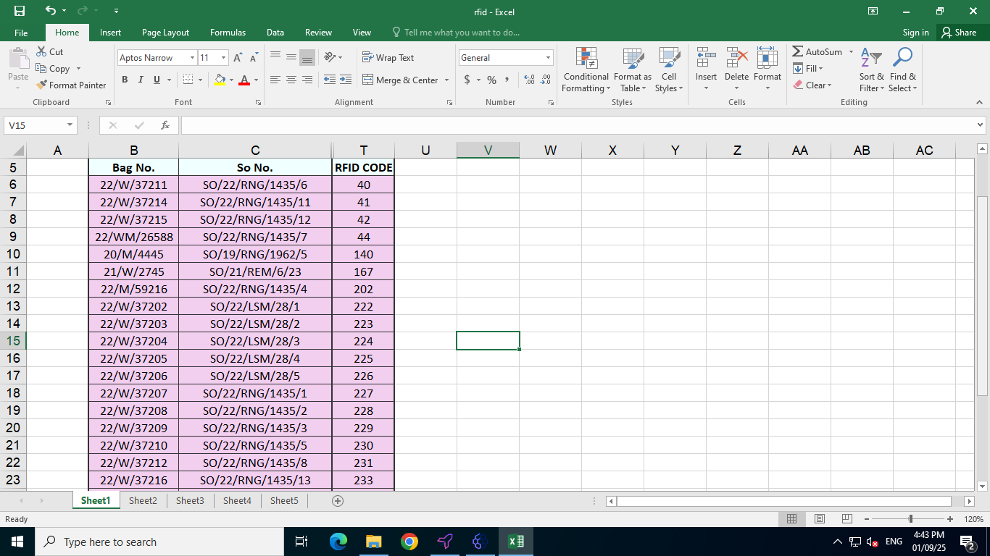

Step 3: Launching the Bot from IBM RPA Launcher
To get into the IBM RPA Launcher, you'll need to log in with your username and password. If you do not have these credentials, please contact your IBM RPA Administrator. Follow the below steps to log into the IBM RPA Launcher and start the bot execution.

- Navigate to the desktop and double-click the "IBM RPA Launcher" icon to start the application.
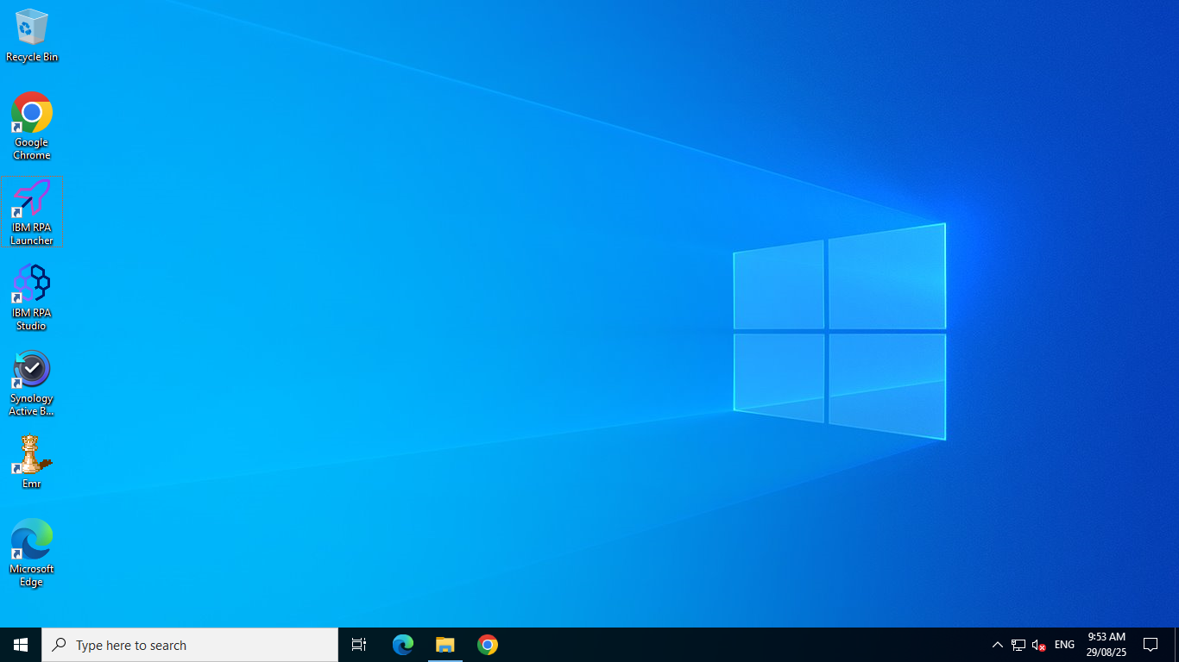

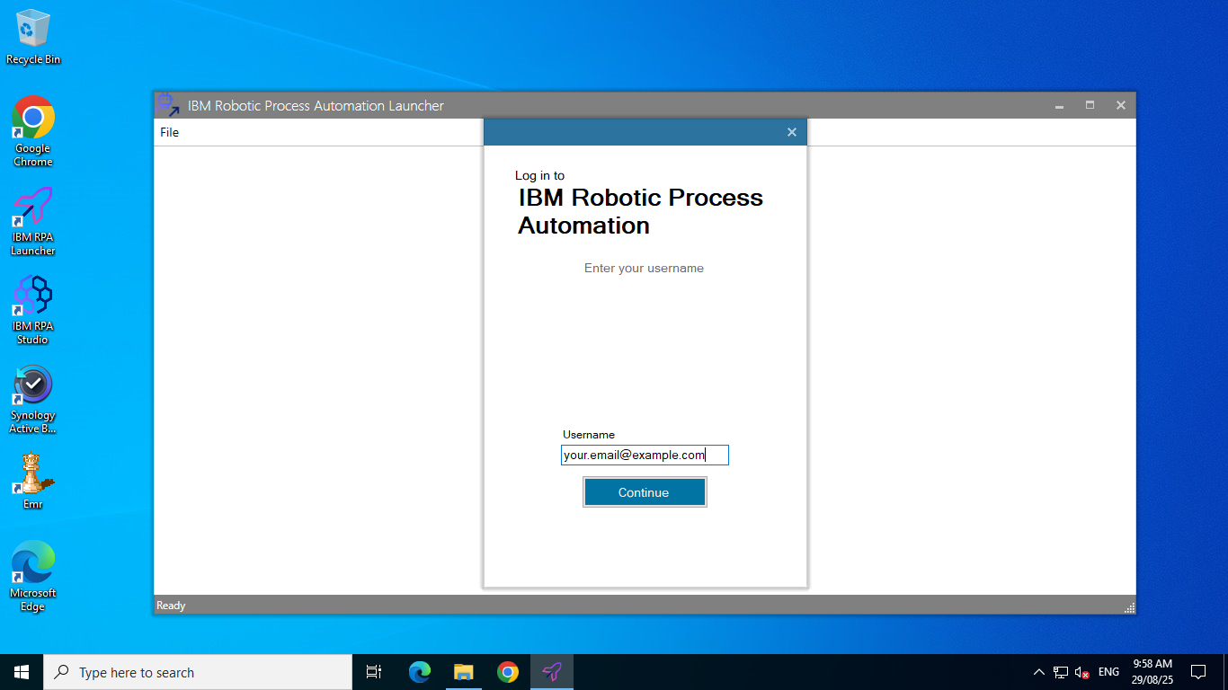
- Obtain your email ID and set your password, then log in to the RPA launcher by entering your email and clicking "Continue."

- On the next screen, input your password and click "Login" to access the launcher.
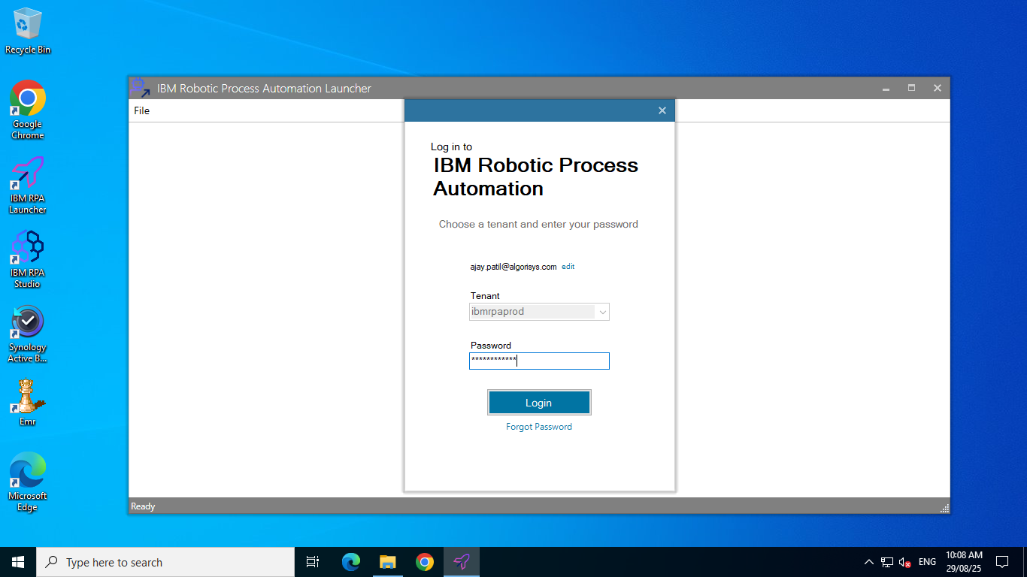

- After login on the launcher's main screen, double-click the "Return Invoice Data Entry" button to initiate the bot's execution. You will see the name "Return Invoice Data Entry" displayed at the top.
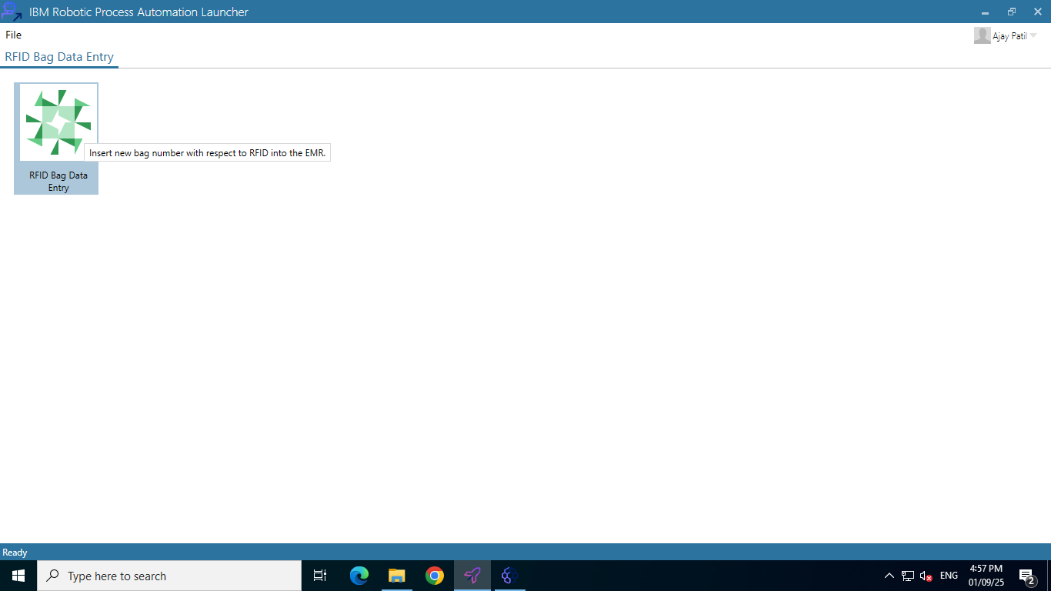

- After successfully initiating the bot, the next crucial step is to minimize the launcher screen. This action will allow you to access the main interface of the Emperor, where you can proceed with further operations. Minimizing the launcher ensures that it does not obstruct your view or interfere with your workflow as you navigate the Emperor Application.

Step 4: Start the Bot Execution
- After invoking the bot, a message dialogue box will appear, prompting you to confirm if you wish to start the bot execution. You will be presented with two buttons: 'Yes' and 'Cancel'.
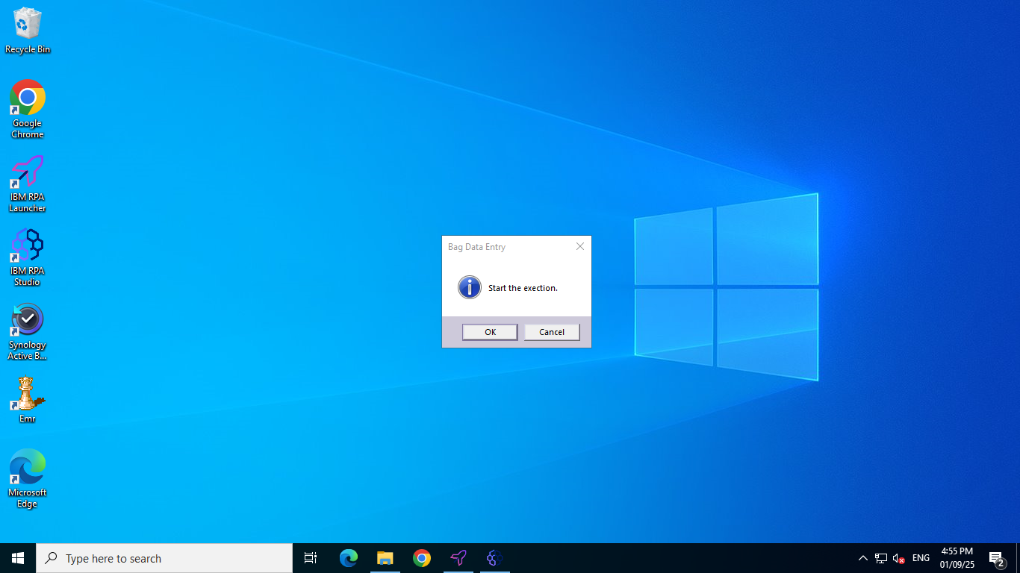

- Now wait until the login window of the emperor system appears and when the window is visible you will need to click on the first input box of the login which is ‘Company Cd’.

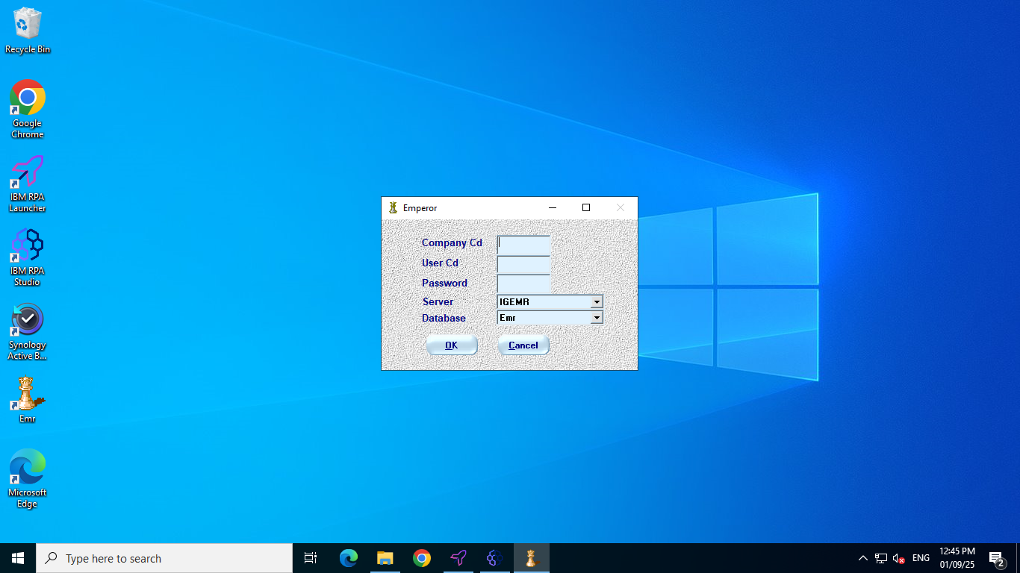

- The bot will automatically insert the login credentials, enter’s company code, usercode given at step ‘2’ and password given at step ‘3’, select’s server and database and log into the Emperor system.
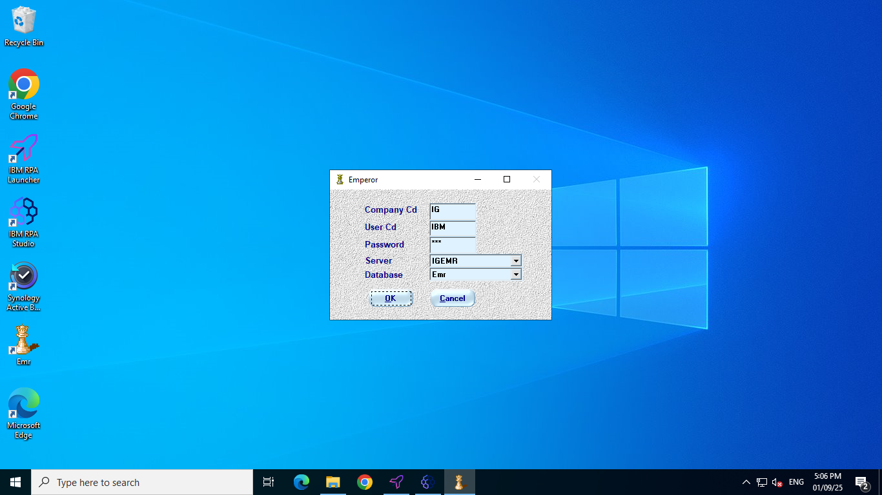
- From the main menu of the Emperor main screen, the bot selects 'Bag Alias Master' from the ‘Bag Master’ from the ‘Master’.

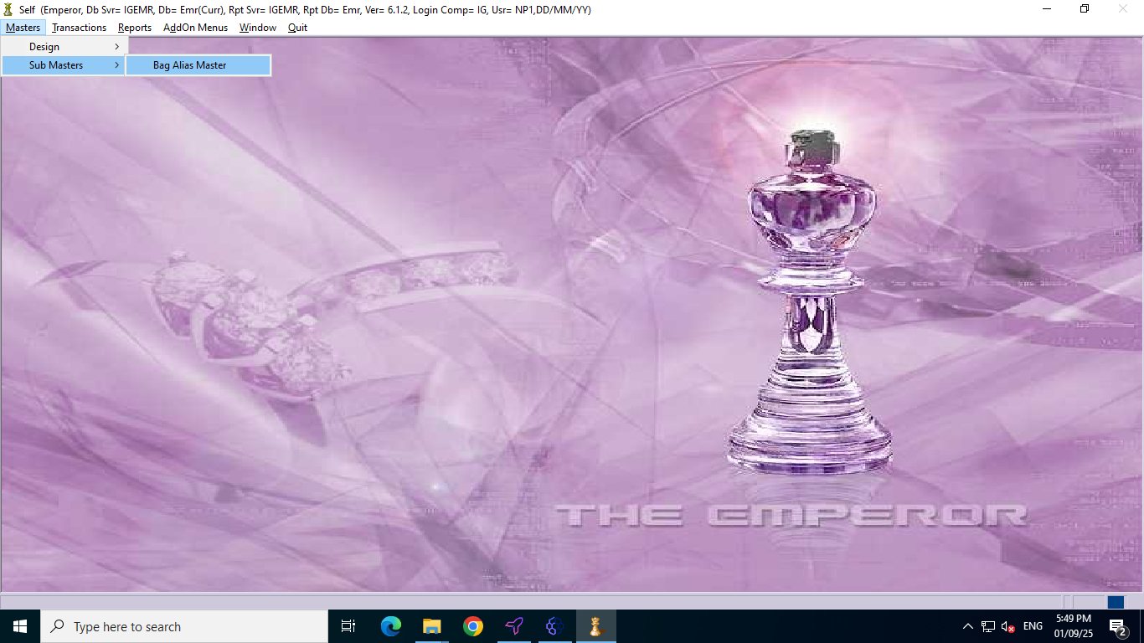

- Now the ‘Bag Alias Master’ form will appear and Bot clicks on the find button from the right bottom corner.
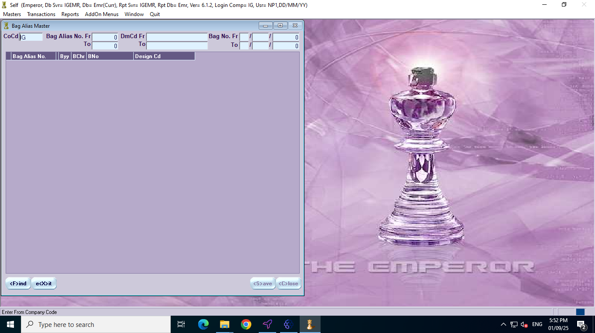

- Once ‘Find’ is clicked, bot proceed to update the bag alias number for the corresponding RFID.

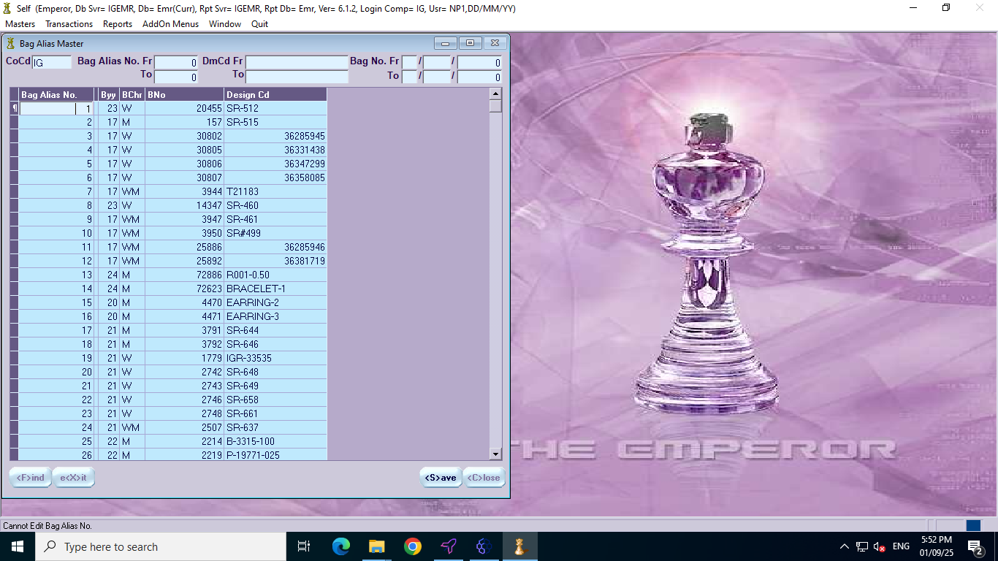

After completing the above steps the bot itself saved the data and closed the bag alias master form and closed the Emperor system.After these steps are done, the bot saves the data automatically. Then, it closes the bag alias master form and completely shuts down the Emperor system.

